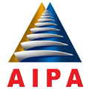

ASEAN INTER-PARLIAMENTARY ASSEMBLY

33rd GENERAL ASSEMBLY
16-22 SEPTEMBER 2012, LOMBOK, INDONESIA

TOPIC FOR DIALOGUE WITH OBSERVER COUNTRIES

- Strengthening human resource development and capacity building;
- Promote collaborates research and strategy transfer in agriculture, food and forestry procedure;
- Energy issues and environmental aspects;
- Strengthening efforts to address climate change adaptation needs;
- Increasing Parliamentary Cooperation between AIPA Members and Observers

